Knowledge Engineering and Data Science – Laboratory Manual
Programme: B.E./B.Tech. (Undergraduate) |
Course: Knowledge Engineering and Data Science | Language: Python 3
Total Experiments: 10 (4 Simple, 4 Medium, 2 Hard) | Total Marks: 100

1. About This Manual
This manual takes students from basic data handling and knowledge representation, through reasoning and ontologies, to evidence-based statistics and hybrid knowledge-and-data systems. Experiments are graded by difficulty so that students build skill step by step, and each one ends with evidence the instructor can check: output, results and a short viva.

1.1 Course outcomes covered
CO | Outcome
CO1 | Represent knowledge using semantic networks, frames, production rules, ontologies and knowledge graphs
CO2 | Build rule-based systems that reason by forward and backward chaining and explain their conclusions
CO3 | Explore, clean, analyse and visualise data with Python
CO4 | Apply inferential statistics (hypothesis tests, ANOVA, chi-square) to draw evidence-based conclusions
CO5 | Acquire knowledge from data using machine learning, and combine it with expert knowledge in a hybrid system

1.2 Experiment overview
No. | Experiment | Level | CO | Bloom level | Duration
1 | Data exploration and cleaning with pandas | Simple | CO3 | K2–K3 | 2 h
2 | Semantic network and inheritance queries | Simple | CO1 | K2–K3 | 2 h
3 | Frames with defaults, inheritance and if-needed procedures | Simple | CO1 | K3 | 2 h
4 | Rule-based system with forward chaining | Simple | CO2 | K3 | 2 h
5 | Backward chaining with a Why/How explanation facility | Medium | CO2 | K3–K4 | 3 h
6 | Building and reasoning over an ontology | Medium | CO1 | K3–K4 | 3 h
7 | Building and querying a knowledge graph | Medium | CO1 | K4 | 3 h
8 | Hypothesis testing, ANOVA and chi-square with evidence | Medium | CO4 | K4 | 3 h
9 | Acquiring rules from data with decision trees | Hard | CO5 | K4–K5 | 4 h
10 | Hybrid decision-support system (knowledge graph, rules and ML) | Hard | CO1, CO2, CO5 | K5–K6 | 6 h

1.3 Software and setup
Item | Requirement
Python | 3.9 or later
Environment | Jupyter Notebook, JupyterLab or VS Code
Libraries | pandas, numpy, matplotlib, scipy, scikit-learn, networkx, rdflib, owlready2
Install command | pip install pandas numpy matplotlib scipy scikit-learn networkx rdflib owlready2
Ontology editor | Protégé (free, from Stanford). A reasoner such as HermiT needs Java installed
Data | Datasets bundled with scikit-learn (Iris, Wine, Breast Cancer), and CSV files given by the instructor or built by students

1.4 Instructions to students
- Predict the result before running code, and note any difference afterwards
- Keep every dataset and program in one folder per experiment
- Do your own work. Copied code that you cannot explain in the viva will lose marks
- Record the library versions used (pip list) so that results can be reproduced

1.5 Record format for every experiment
Aim, tools, algorithm, flowchart, program, input data, output, calculation or analysis, result and inference, and viva answers.

1.6 Marking scheme
Level | Marks per experiment | Split
Simple (4) | 8 | Aim and algorithm 2, program 3, output and result 2, viva 1
Medium (4) | 10 | Aim and algorithm 2, program 3, output and analysis 3, viva 2
Hard (2) | 14 | Design 3, program 4, evaluation and evidence 4, report 1, viva 2
Total | 100 | 4 × 8 + 4 × 10 + 2 × 14

PART A – SIMPLE EXPERIMENTS

Experiment 1: Data Exploration and Cleaning with pandas
Level: Simple | CO: CO3 | Duration: 2 hours | Marks: 8
Aim: To load a dataset, inspect it, handle missing and inconsistent values, and summarise it using descriptive statistics and charts.
Tools: Python, pandas, matplotlib
Dataset: student_marks.csv supplied by the instructor, with columns reg_no, department, gender, attendance, internal, final_exam, study_hours. Include a few blank cells, one repeated row and an impossible value (for example attendance of 140), so there is something to clean.
Procedure:
- Load the file with pd.read_csv and display head(), shape, info() and describe()
- Count missing values for each column with isna().sum()
- Fill missing numbers with the median and missing categories with the mode. State why the median was chosen
- Remove duplicate rows and correct or drop impossible values
- Compute the mean, median, standard deviation, minimum and maximum of final_exam. Group by department and compare the means
- Draw a histogram of final_exam, a box plot by department and a scatter plot of study_hours against final_exam
- Compute the correlation between study_hours and final_exam
Code :
# EXPERIMENT 1: DATA EXPLORATION AND CLEANING WITH PANDAS

# 1. Import required libraries
import pandas as pd
import numpy as np
import matplotlib.pyplot as plt

# 2. Create student marks dataset
data = {
'reg_no': [101, 102, 103, 104, 105, 106, 107, 108, 109, 110, 111, 112],
'department': ['AIDS', 'CSE', 'IT', 'AIDS', 'CSE', 'IT',
'AIDS', 'CSE', 'IT', 'AIDS', 'CSE', 'IT'],
'gender': ['Male', 'Female', 'Male', 'Female', None, 'Male',
'Female', 'Male', 'Female', 'Male', 'Female', 'Male'],
'attendance': [90, 85, 75, 95, 80, 140, 88, None, 92, 78, 86, 91],
'internal': [85, 80, 70, 90, 75, 65, 88, 82, 79, 72, 84, 89],
'final_exam': [88, 82, 72, 94, 78, 68, 91, 85, None, 75, 87, 93],
'study_hours': [4, 3, 2, 5, 3, 2, 5, 4, 3, 2, 4, 5]
}

df = pd.DataFrame(data)

# Add one duplicate record
df = pd.concat([df, df.iloc[[0]]], ignore_index=True)

# Save and load CSV file
df.to_csv('student_marks.csv', index=False)
df = pd.read_csv('student_marks.csv')

print("========== ORIGINAL DATASET ==========")
print(df)

# 3. Explore the dataset
print("\n========== FIRST FIVE RECORDS ==========")
print(df.head())

print("\n========== DATASET SHAPE ==========")
print(df.shape)

print("\n========== DATASET INFORMATION ==========")
df.info()

print("\n========== DESCRIPTIVE STATISTICS ==========")
print(df.describe())

# 4. Identify missing values
print("\n========== MISSING VALUES ==========")
print(df.isnull().sum())

# 5. Correct impossible attendance values
df.loc[df['attendance'] > 100, 'attendance'] = np.nan

# 6. Fill missing numerical values using median
numeric_columns = ['attendance', 'internal', 'final_exam', 'study_hours']

for col in numeric_columns:
df[col] = df[col].fillna(df[col].median())

# 7. Fill missing categorical values using mode
categorical_columns = ['department', 'gender']

for col in categorical_columns:
df[col] = df[col].fillna(df[col].mode()[0])

# 8. Remove duplicate records
df = df.drop_duplicates()

print("\n========== CLEANED DATASET ==========")
print(df)

print("\n========== MISSING VALUES AFTER CLEANING ==========")
print(df.isnull().sum())

print("\nFinal Dataset Shape:", df.shape)

# 9. Calculate statistical measures
print("\n========== FINAL EXAM STATISTICS ==========")
print("Mean:", df['final_exam'].mean())
print("Median:", df['final_exam'].median())
print("Standard Deviation:", df['final_exam'].std())
print("Minimum:", df['final_exam'].min())
print("Maximum:", df['final_exam'].max())

# 10. Department-wise average marks
print("\n========== DEPARTMENT-WISE MEAN ==========")
print(df.groupby('department')['final_exam'].mean())

# 11. Histogram
plt.figure(figsize=(7, 5))
plt.hist(df['final_exam'], bins=5, edgecolor='black')
plt.title('Distribution of Final Exam Marks')
plt.xlabel('Final Exam Marks')
plt.ylabel('Number of Students')
plt.show()

# 12. Box Plot
plt.figure(figsize=(7, 5))
df.boxplot(column='final_exam', by='department')
plt.title('Final Exam Marks by Department')
plt.suptitle('')
plt.xlabel('Department')
plt.ylabel('Final Exam Marks')
plt.show()

# 13. Scatter Plot
plt.figure(figsize=(7, 5))
plt.scatter(df['study_hours'], df['final_exam'])
plt.title('Study Hours vs Final Exam Marks')
plt.xlabel('Study Hours')
plt.ylabel('Final Exam Marks')
plt.show()

# 14. Correlation
print("\n========== CORRELATION ==========")
correlation = df['study_hours'].corr(df['final_exam'])
print("Correlation:", correlation)

# 15. Save cleaned dataset
df.to_csv('student_marks_clean.csv', index=False)

print("\nCleaned dataset saved successfully!")
print("EXPERIMENT 1 COMPLETED SUCCESSFULLY!")

Expected output: A cleaned dataset (saved as student_marks_clean.csv), a table of summary statistics and three labelled charts.

========== ORIGINAL DATASET ==========
reg_no department gender attendance internal final_exam study_hours
0 101 AIDS Male 90.0 85 88.0 4
1 102 CSE Female 85.0 80 82.0 3
2 103 IT Male 75.0 70 72.0 2
3 104 AIDS Female 95.0 90 94.0 5
4 105 CSE NaN 80.0 75 78.0 3
5 106 IT Male 140.0 65 68.0 2
6 107 AIDS Female 88.0 88 91.0 5
7 108 CSE Male NaN 82 85.0 4
8 109 IT Female 92.0 79 NaN 3
9 110 AIDS Male 78.0 72 75.0 2
10 111 CSE Female 86.0 84 87.0 4
11 112 IT Male 91.0 89 93.0 5
12 101 AIDS Male 90.0 85 88.0 4

========== FIRST FIVE RECORDS ==========
reg_no department gender attendance internal final_exam study_hours
0 101 AIDS Male 90.0 85 88.0 4
1 102 CSE Female 85.0 80 82.0 3
2 103 IT Male 75.0 70 72.0 2
3 104 AIDS Female 95.0 90 94.0 5
4 105 CSE NaN 80.0 75 78.0 3

========== DATASET SHAPE ==========
(13, 7)

========== DATASET INFORMATION ==========
<class 'pandas.core.frame.DataFrame'>
RangeIndex: 13 entries, 0 to 12
Data columns (total 7 columns):
# Column Non-Null Count Dtype
--- ------ -------------- -----
0 reg_no 13 non-null int64
1 department 13 non-null object
2 gender 12 non-null object
3 attendance 12 non-null float64
4 internal 13 non-null int64
5 final_exam 12 non-null float64
6 study_hours 13 non-null int64
dtypes: float64(2), int64(3), object(2)
memory usage: 860.0+ bytes

========== DESCRIPTIVE STATISTICS ==========
reg_no attendance internal final_exam study_hours
count 13.000000 12.000000 13.000000 12.000000 13.000000
mean 106.076923 90.833333 80.307692 83.416667 3.538462
std 3.774068 16.612336 7.792995 8.468748 1.126601
min 101.000000 75.000000 65.000000 68.000000 2.000000
25% 103.000000 83.750000 75.000000 77.250000 3.000000
50% 106.000000 89.000000 82.000000 86.000000 4.000000
75% 109.000000 91.250000 85.000000 88.750000 4.000000
max 112.000000 140.000000 90.000000 94.000000 5.000000

========== MISSING VALUES ==========
reg_no 0
department 0
gender 1
attendance 1
internal 0
final_exam 1
study_hours 0
dtype: int64

========== CLEANED DATASET ==========
reg_no department gender attendance internal final_exam study_hours
0 101 AIDS Male 90.0 85 88.0 4
1 102 CSE Female 85.0 80 82.0 3
2 103 IT Male 75.0 70 72.0 2
3 104 AIDS Female 95.0 90 94.0 5
4 105 CSE Male 80.0 75 78.0 3
5 106 IT Male 88.0 65 68.0 2
6 107 AIDS Female 88.0 88 91.0 5
7 108 CSE Male 88.0 82 85.0 4
8 109 IT Female 92.0 79 86.0 3
9 110 AIDS Male 78.0 72 75.0 2
10 111 CSE Female 86.0 84 87.0 4
11 112 IT Male 91.0 89 93.0 5

========== MISSING VALUES AFTER CLEANING ==========
reg_no 0
department 0
gender 0
attendance 0
internal 0
final_exam 0
study_hours 0
dtype: int64

Final Dataset Shape: (12, 7)

========== FINAL EXAM STATISTICS ==========
Mean: 83.25
Median: 85.5
Standard Deviation: 8.389658135845801
Minimum: 68.0
Maximum: 94.0

========== DEPARTMENT-WISE MEAN ==========
department
AIDS 87.00
CSE 83.00
IT 79.75
Name: final_exam, dtype: float64
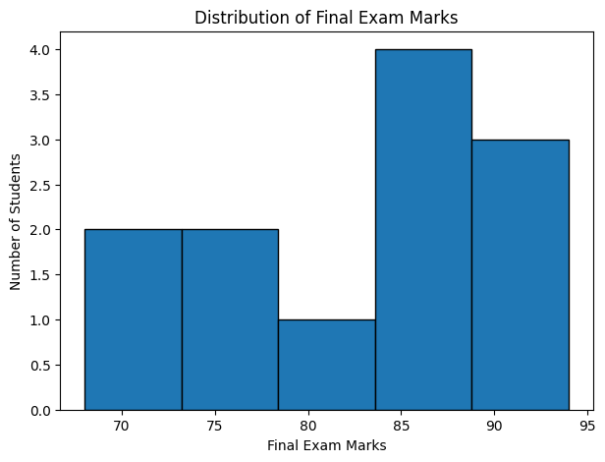
<Figure size 700x500 with 0 Axes>
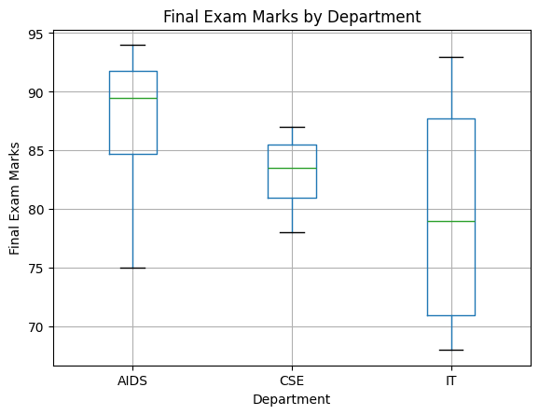
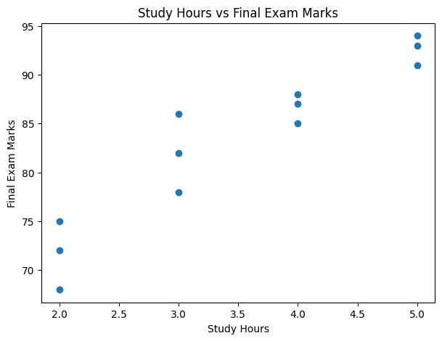
========== CORRELATION ==========
Correlation: 0.9418458005432
Cleaned dataset saved successfully!
EXPERIMENT 1 COMPLETED SUCCESSFULLY!

Experiment 2: Semantic Network and Inheritance Queries
Level: Simple | CO: CO1 | Duration: 2 hours | Marks: 8
Aim: To represent a domain as a semantic network and to answer questions by inheritance and path search.
Tools: Python, networkx, matplotlib
Domain: Animals (Animal, Bird, Fish, Canary, Penguin, Tweety) or a domain of your own, such as vehicles or university staff.
Procedure:
- Create a directed graph with networkx.DiGraph. Add nodes for classes and individuals
- Add edges with a relation attribute: is-a, instance-of, has-part, can, colour
- Draw the network with labelled edges
- Write a function inherits(node, relation) that looks at the node, then follows is-a and instance-of links upward until it finds the relation, and returns the most specific value
- Test with: Can Tweety fly? Does Tweety have wings? Can a penguin fly? (add a cannot fly value at Penguin to test overriding)
- Write a function that finds the path between two concepts (for example Tweety and Animal) using nx.shortest_path

Code:
EXPERIMENT 2: SEMANTIC NETWORK AND INHERITANCE QUERIES

# 1. Import required libraries
import networkx as nx
import matplotlib.pyplot as plt

# 2. Create a directed graph
G = nx.DiGraph()

# 3. Add nodes (Classes and Individuals)
nodes = [
"Animal", "Bird", "Fish",
"Canary", "Penguin", "Tweety"
]

G.add_nodes_from(nodes)

# 4. Add relationships between nodes
G.add_edge("Bird", "Animal", relation="is-a")
G.add_edge("Fish", "Animal", relation="is-a")
G.add_edge("Canary", "Bird", relation="is-a")
G.add_edge("Penguin", "Bird", relation="is-a")
G.add_edge("Tweety", "Canary", relation="instance-of")

# 5. Add properties to nodes
properties = {
"Animal": {"can": "move"},
"Bird": {"can": "fly", "has-part": "wings"},
"Fish": {"can": "swim"},
"Canary": {"colour": "yellow"},
"Penguin": {"can": "cannot fly"},
"Tweety": {"colour": "yellow"}
}

nx.set_node_attributes(G, properties)

# 6. Display semantic network
plt.figure(figsize=(10, 7))

pos = nx.spring_layout(G, seed=42)

nx.draw(
G, pos,
with_labels=True,
node_color="lightblue",
node_size=3000,
font_size=10,
font_weight="bold",
arrows=True
)

edge_labels = nx.get_edge_attributes(G, "relation")
nx.draw_networkx_edge_labels(
G, pos,
edge_labels=edge_labels,
font_color="red"
)

plt.title("Semantic Network of Animals")
plt.show()

# 7. Inheritance function
def inherits(node, relation):
current = node
visited = set()

while current is not None and current not in visited:
visited.add(current)

# Check local property first
if relation in G.nodes[current]:
return G.nodes[current][relation]

# Find parent node
parents = [
neighbor for neighbor in G.successors(current)
if G[current][neighbor]["relation"] in ["is-a", "instance-of"]
]

current = parents[0] if parents else None

return "Property not found"

# 8. Test inheritance queries
print("\n========== INHERITANCE QUERIES ==========")

print("Can Tweety fly?:", inherits("Tweety", "can"))
print("Does Tweety have wings?:", inherits("Tweety", "has-part"))
print("Can Penguin fly?:", inherits("Penguin", "can"))
print("What is Tweety's colour?:", inherits("Tweety", "colour"))
print("Can a Fish swim?:", inherits("Fish", "can"))

# 9. Find path between two concepts
print("\n========== PATH SEARCH ==========")

source = "Tweety"
target = "Animal"

path = nx.shortest_path(G, source, target)

print("Path from", source, "to", target, ":")
print(" -> ".join(path))

# 10. Display all relationships
print("\n========== SEMANTIC NETWORK RELATIONSHIPS ==========")

for u, v, data in G.edges(data=True):
print(u, "--", data["relation"], "-->", v)

print("\nEXPERIMENT 2 COMPLETED SUCCESSFULLY!")

Expected output: A drawing of the network, answers to at least five queries with the path of links followed, and a note on how the exception was handled.

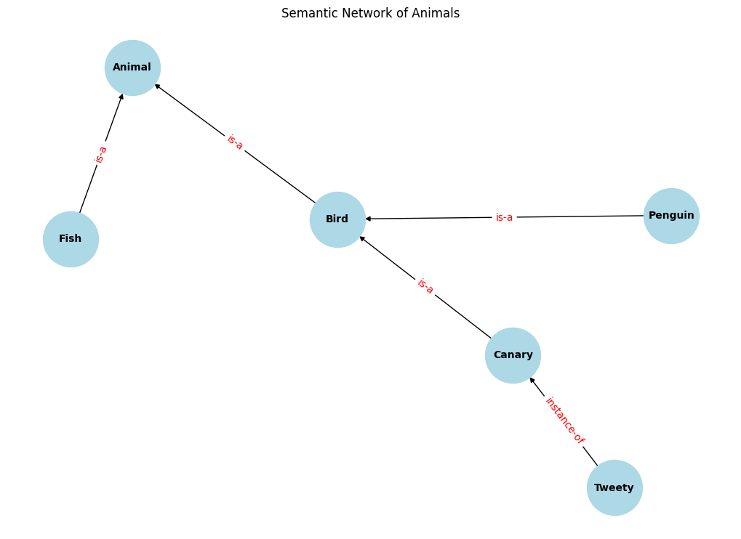
========== INHERITANCE QUERIES ==========
Can Tweety fly?: fly
Does Tweety have wings?: wings
Can Penguin fly?: cannot fly
What is Tweety's colour?: yellow
Can a Fish swim?: swim

========== PATH SEARCH ==========
Path from Tweety to Animal :
Tweety -> Canary -> Bird -> Animal

========== SEMANTIC NETWORK RELATIONSHIPS ==========
Bird -- is-a --> Animal
Fish -- is-a --> Animal
Canary -- is-a --> Bird
Penguin -- is-a --> Bird
Tweety -- instance-of --> Canary

Experiment 3: Frames with Defaults, Inheritance and If-Needed Procedures
Level: Simple | CO: CO1 | Duration: 2 hours | Marks: 8
Aim: To implement frames in Python with slots, default values, inheritance and attached procedures.
Tools: Python (classes and dictionaries)
Domain: Vehicle, Car, MyCar (or Student, UGStudent, an individual student).
Procedure:
- Implement a Frame class holding a name, an optional parent, and a dictionary of slots. Each slot stores a value, a default and optionally an if_needed function
- Write get(slot) so that it checks, in order: the frame's own value; its if-needed procedure; its default; then the parent frame
- Write set(slot, value) that runs an optional if_added procedure (a "demon"), for example one that prints a warning when mileage is set below zero
- Build the hierarchy Vehicle, Car and MyCar. Give Vehicle wheels = 4 as default and a mileage slot computed by an if-needed function from odometer and fuel_used
- Print the value of each slot for MyCar and say whether it came from the frame, a default, a procedure or a parent

Code
# EXPERIMENT 3: FRAMES AND INHERITANCE

# 1. Create Frame class
class Frame:
def __init__(self, name, parent=None):
self.name = name
self.parent = parent
self.slots = {}

# Add slot
def set(self, slot, value):
if slot == "mileage" and value < 0:
print("Warning: Mileage cannot be negative!")
return
self.slots[slot] = value

# Get slot value
def get(self, slot):
if slot in self.slots:
return self.slots[slot]

if self.parent:
return self.parent.get(slot)

return "Not Available"

# 2. Create frame hierarchy
Vehicle = Frame("Vehicle")
Vehicle.set("wheels", 4)
Vehicle.set("fuel", "Petrol")

Car = Frame("Car", Vehicle)
Car.set("brand", "Toyota")

MyCar = Frame("MyCar", Car)
MyCar.set("colour", "White")
MyCar.set("odometer", 15000)

# 3. If-needed procedure for mileage
def calculate_mileage(odometer, fuel_used):
return odometer / fuel_used

MyCar.set("fuel_used", 100)

# 4. Display inherited and local values
print("========== FRAME INFORMATION ==========")

print("Vehicle Wheels:", MyCar.get("wheels"))
print("Fuel Type:", MyCar.get("fuel"))
print("Car Brand:", MyCar.get("brand"))
print("Car Colour:", MyCar.get("colour"))
print("Odometer:", MyCar.get("odometer"))

# Calculate mileage using procedure
mileage = calculate_mileage(
MyCar.get("odometer"),
MyCar.get("fuel_used")
)

print("Mileage:", mileage, "km/litre")

# 5. Demonstrate demon (if-added procedure)
print("\n========== DEMONSTRATION ==========")
MyCar.set("mileage", -10)

print("\nEXPERIMENT 3 COMPLETED SUCCESSFULLY!")

Expected output: A working frame class, a printed table of slot values with the source of each, and a demonstration of one demon firing.

========== FRAME INFORMATION ==========
Vehicle Wheels: 4
Fuel Type: Petrol
Car Brand: Toyota
Car Colour: White
Odometer: 15000
Mileage: 150.0 km/litre

========== DEMONSTRATION ==========
Warning: Mileage cannot be negative!

EXPERIMENT 3 COMPLETED SUCCESSFULLY!

Experiment 4: Rule-Based System with Forward Chaining
Level: Simple | CO: CO2 | Duration: 2 hours | Marks: 8
Aim: To build a small production system that applies IF-THEN rules to a set of facts by forward chaining.
Tools: Python
Domain: Loan eligibility, crop advice or laptop fault diagnosis. Use at least eight rules.
Procedure:
- Store each rule as a pair: a set of conditions and a conclusion, for example ({"income_ok", "credit_good"}, "approve")
- Store the starting facts in a set (working memory)
- Write the recognise-act cycle: find all rules whose conditions are all in the facts and whose conclusion is not already there; pick one (first match); add its conclusion; repeat until nothing new can be added
- Print each cycle: which rules matched (the conflict set), which fired, and the current facts
- Test with three different sets of starting facts, including one that leads to no conclusion
- Add a second conflict resolution strategy (most specific rule first) and compare the order of firing
- Code :
# EXPERIMENT 4: FORWARD CHAINING

# 1. Define IF-THEN rules
rules = [
({"income_ok"}, "eligible_income"),
({"credit_good"}, "eligible_credit"),
({"eligible_income", "eligible_credit"}, "loan_approved"),
({"salary_high"}, "income_ok"),
({"credit_score_good"}, "credit_good"),
({"loan_approved"}, "low_risk"),
({"low_risk", "job_stable"}, "premium_customer"),
({"income_low"}, "loan_rejected")
]

# 2. Initial facts
facts = {"salary_high", "credit_score_good", "job_stable"}

# 3. Forward chaining function
def forward_chaining(facts, rules):
facts = set(facts)
cycle = 1

while True:
new_facts = []

for conditions, conclusion in rules:
if conditions.issubset(facts) and conclusion not in facts:
new_facts.append(conclusion)

if not new_facts:
break

print("\nCycle:", cycle)
for fact in new_facts:
print("Rule fired ->", fact)
facts.add(fact)

print("Current Facts:", facts)
cycle += 1

return facts

# 4. Execute forward chaining
print("Initial Facts:", facts)

result = forward_chaining(facts, rules)

# 5. Final conclusions
print("\n========== FINAL CONCLUSIONS ==========")

for fact in result:
print(fact)

print("\nEXPERIMENT 4 COMPLETED SUCCESSFULLY!")

Expected output: A trace table with one row per cycle, and the final conclusions for each test.
Initial Facts: {'job_stable', 'credit_score_good', 'salary_high'}

Cycle: 1
Rule fired -> income_ok
Rule fired -> credit_good
Current Facts: {'income_ok', 'job_stable', 'credit_score_good', 'credit_good', 'salary_high'}

Cycle: 2
Rule fired -> eligible_income
Rule fired -> eligible_credit
Current Facts: {'income_ok', 'job_stable', 'eligible_income', 'eligible_credit', 'credit_score_good', 'credit_good', 'salary_high'}

Cycle: 3
Rule fired -> loan_approved
Current Facts: {'income_ok', 'job_stable', 'eligible_income', 'eligible_credit', 'credit_score_good', 'credit_good', 'loan_approved', 'salary_high'}

Cycle: 4
Rule fired -> low_risk
Current Facts: {'income_ok', 'job_stable', 'low_risk', 'eligible_income', 'eligible_credit', 'credit_score_good', 'credit_good', 'loan_approved', 'salary_high'}

Cycle: 5
Rule fired -> premium_customer
Current Facts: {'income_ok', 'job_stable', 'low_risk', 'premium_customer', 'eligible_income', 'eligible_credit', 'credit_score_good', 'credit_good', 'loan_approved', 'salary_high'}

========== FINAL CONCLUSIONS ==========
income_ok
job_stable
low_risk
premium_customer
eligible_income
eligible_credit
credit_score_good
credit_good
loan_approved
salary_high

EXPERIMENT 4 COMPLETED SUCCESSFULLY!

PART B – MEDIUM EXPERIMENTS

Experiment 5: Backward Chaining with a Why/How Explanation Facility
Level: Medium | CO: CO2 | Duration: 3 hours | Marks: 10
Aim: To implement goal-driven reasoning that asks the user for missing facts and can explain why it asks and how it reached a conclusion.
Tools: Python
Domain: Diagnosis of a plant disease, a network fault or a medical triage assistant (educational use only). Use at least 12 rules and 3 or more possible conclusions.
Procedure:
- Represent rules as rule_id, [conditions], conclusion. Keep facts in a dictionary of fact: True/False
- Write a recursive function prove(goal): if the goal is a known fact, return it; if there are rules concluding the goal, try each by proving all its conditions; if the goal is askable (a basic observation), ask the user yes or no and store the answer
- Keep a proof trace (the rules used and the facts asked)
- Add the Why facility: when the system asks a question, the user can type why to see the rule and goal that required the question
- Add the How facility: after a conclusion, print the chain of rules and facts that proved it
- Run at least four consultations covering different conclusions and one that proves nothing
CODE:
EXPERIMENT 5: BACKWARD CHAINING

# 1. Define rules
rules = [
(["yellow_leaves", "dry_soil"], "water_deficiency"),
(["yellow_leaves", "wet_soil"], "root_rot"),
(["brown_spots", "high_humidity"], "fungal_disease"),
(["water_deficiency"], "plant_needs_water"),
(["root_rot"], "plant_disease"),
(["fungal_disease"], "plant_disease"),
(["yellow_leaves", "brown_spots"], "serious_condition"),
(["dry_soil", "wilting"], "water_deficiency"),
(["wet_soil", "bad_smell"], "root_rot"),
(["fungal_disease", "high_humidity"], "spread_risk"),
(["plant_needs_water"], "watering_required"),
(["plant_disease"], "treatment_required")
]

# 2. Store known facts
facts = {
"yellow_leaves": True,
"dry_soil": True,
"brown_spots": False,
"high_humidity": False,
"wet_soil": False,
"wilting": False,
"bad_smell": False
}

# 3. Store explanation trace
trace = []

# 4. Backward chaining function
def prove(goal):
if facts.get(goal) is True:
return True

if facts.get(goal) is False:
return False

for conditions, conclusion in rules:
if conclusion == goal:
print("\nWhy: Checking", goal)
trace.append("Rule: " + str(conditions) + " -> " + goal)

if all(prove(condition) for condition in conditions):
return True

# Ask user for unknown facts
answer = input("Is " + goal + " present? (yes/no/why): ").lower()

if answer == "why":
print("Because it is required to prove:", goal)
return prove(goal)

facts[goal] = (answer == "yes")
return facts[goal]

# 5. Test backward chaining
goal = "plant_disease"

print("========== BACKWARD CHAINING ==========")

if prove(goal):
print("\nConclusion: Plant disease detected.")
else:
print("\nConclusion: Plant disease not detected.")

# 6. How explanation
print("\n========== HOW EXPLANATION ==========")

for step in trace:
print(step)

print("\nEXPERIMENT 5 COMPLETED SUCCESSFULLY!")

Expected output: Recorded consultations with Why and How outputs, and a short comparison of the number of questions asked by backward chaining versus the number of rules checked by forward
chaining on the same rule base.

========== BACKWARD CHAINING ==========

Why: Checking plant_disease

Why: Checking root_rot

Why: Checking root_rot
Is root_rot present? (yes/no/why): yes

Conclusion: Plant disease detected.

========== HOW EXPLANATION ==========
Rule: ['root_rot'] -> plant_disease
Rule: ['yellow_leaves', 'wet_soil'] -> root_rot
Rule: ['wet_soil', 'bad_smell'] -> root_rot

EXPERIMENT 5 COMPLETED SUCCESSFULLY!

Experiment 6: Building and Reasoning over an Ontology
Level: Medium | CO: CO1 | Duration: 3 hours | Marks: 10
Aim: To design a small ontology, create instances, and use a reasoner to check consistency and infer new facts.
Tools: Protégé with the HermiT reasoner, or Python owlready2
Domain: University (Person, Student, Faculty, Course, Department) or Hospital, Library or Retail.
Procedure:
- Write 5 competency questions the ontology must answer (for example: Which courses does Asha attend?)
- Create at least 8 classes with a class hierarchy (Student and Faculty as subclasses of Person)
- Create object properties (enrolledIn, teaches, belongsTo) with domain and range, and data properties (hasName, hasCredits)
- Add restrictions: Student and Faculty are disjoint; a Course must have at least one teacher
- Create at least 10 individuals with their property values
- Run the reasoner. Record the inferred class membership (for example, a person who enrolledIn a course is inferred to be a Student through the domain axiom)
- Deliberately create an inconsistency (a person who is both Student and Faculty) and record what the reasoner reports
- Answer the competency questions with queries (the DL Query tab in Protégé, or SPARQL through rdflib)
CODE:
EXPERIMENT 6: BUILDING AND REASONING OVER AN ONTOLOGY
!pip install owlready2
from owlready2 import *

# 1. Create ontology
onto = get_ontology("http://example.org/university.owl")

with onto:

# 2. Create classes
class Person(Thing):
pass

class Student(Person):
pass

class Faculty(Person):
pass

class Course(Thing):
pass

class Department(Thing):
pass

# 3. Create object properties
class enrolledIn(ObjectProperty):
domain = [Student]
range = [Course]

class teaches(ObjectProperty):
domain = [Faculty]
range = [Course]

class belongsTo(ObjectProperty):
domain = [Person]
range = [Department]

# 4. Create data property
class hasName(DataProperty):
range = [str]

# 5. Create individuals
s1 = Student("Student1")
f1 = Faculty("Faculty1")
c1 = Course("Python")
d1 = Department("AIDS")

s1.hasName = ["Arun"]
f1.hasName = ["Kumar"]

s1.enrolledIn = [c1]
f1.teaches = [c1]
s1.belongsTo = [d1]

# 6. Define disjoint classes
AllDisjoint([Student, Faculty])

# 7. Display ontology information
print("========== ONTOLOGY ==========")

print("Classes:", list(onto.classes()))

print("\nIndividuals:", list(onto.individuals()))

print("\nStudent Name:", s1.hasName)
print("Enrolled Course:", s1.enrolledIn)
print("Faculty Teaching:", f1.teaches)

# 8. Run reasoner
with onto:
sync_reasoner(infer_property_values=True)

# 9. Display inferred facts
print("\n========== REASONING RESULTS ==========")

for individual in onto.individuals():
print(individual.name, ":", list(individual.is_a))

# 10. Save ontology
onto.save(file="university.owl", format="rdfxml")

print("\nOntology saved successfully!")
print("EXPERIMENT 6 COMPLETED SUCCESSFULLY!")

Expected output: The ontology file (.owl), a diagram of the class hierarchy, the list of inferred facts, the inconsistency report and the answers to the competency questions.

Collecting rdflib
Downloading rdflib-7.6.0-py3-none-any.whl.metadata (12 kB)
Requirement already satisfied: networkx in /usr/local/lib/python3.13/dist-packages (3.7)
Requirement already satisfied: matplotlib in /usr/local/lib/python3.13/dist-packages (3.10.0)
Requirement already satisfied: pyparsing<4,>=2.1.0 in /usr/local/lib/python3.13/dist-packages (from rdflib) (3.3.3)
Requirement already satisfied: contourpy>=1.0.1 in /usr/local/lib/python3.13/dist-packages (from matplotlib) (1.4.0)
Requirement already satisfied: cycler>=0.10 in /usr/local/lib/python3.13/dist-packages (from matplotlib) (0.12.1)
Requirement already satisfied: fonttools>=4.22.0 in /usr/local/lib/python3.13/dist-packages (from matplotlib) (4.67.0)
Requirement already satisfied: kiwisolver>=1.3.1 in /usr/local/lib/python3.13/dist-packages (from matplotlib) (1.5.1)
Requirement already satisfied: numpy>=1.23 in /usr/local/lib/python3.13/dist-packages (from matplotlib) (2.1.3)
Requirement already satisfied: packaging>=20.0 in /usr/local/lib/python3.13/dist-packages (from matplotlib) (26.3)
Requirement already satisfied: pillow>=8 in /usr/local/lib/python3.13/dist-packages (from matplotlib) (11.3.0)
Requirement already satisfied: python-dateutil>=2.7 in /usr/local/lib/python3.13/dist-packages (from matplotlib) (2.9.0.post0)
Requirement already satisfied: six>=1.5 in /usr/local/lib/python3.13/dist-packages (from python-dateutil>=2.7->matplotlib) (1.17.0)
Downloading rdflib-7.6.0-py3-none-any.whl (615 kB)
━━━━━━━━━━━━━━━━━━━━━━━━━━━━━━━━━━━━━━━━ 615.4/615.4 kB 8.7 MB/s 0:00:00
Installing collected packages: rdflib
Successfully installed rdflib-7.6.0

Experiment 7: Building and Querying a Knowledge Graph
Level: Medium | CO: CO1 | Duration: 3 hours | Marks: 10
Aim: To construct a knowledge graph from tabular and text data, resolve duplicate entities, and query it.
Tools: Python, pandas, rdflib, networkx
Data: Two CSV files, people.csv (person_id, name, department, city) and works.csv (person_id, project, role), plus 10 sentences of text such as "Asha works on Project Alpha at Anna University". Include two spellings of the same person (for example "A. Kumar" and "Arun Kumar").
Procedure:
- Define a namespace and a small schema (classes Person, Project, Department, City; properties worksOn, memberOf, livesIn)
- Convert each CSV row into RDF triples with rdflib and add them to a graph
- Extract simple triples from the sentences by pattern matching (for example X works on Y) and add them
- Perform entity resolution: detect the duplicate person using a simple rule (same department and similar name, using difflib.SequenceMatcher) and merge them
- Write at least five SPARQL queries, for example: who works on Project Alpha; who is in the same department as Asha; which projects involve people in Chennai
- Convert the graph to networkx, compute the degree of each node and find the most connected entity
- Draw the graph

CODE:
# EXPERIMENT 7: BUILDING AND QUERYING A KNOWLEDGE GRAPH

import networkx as nx
import matplotlib.pyplot as plt
from rdflib import Graph, Namespace, Literal, RDF

# 1. Create knowledge graph
g = Graph()
EX = Namespace("http://example.org/")

# 2. Add student information (using underscores instead of spaces to ensure valid URIs)
students = [
("Arun", "AIDS", "Chennai", "Project_Alpha"),
("Kumar", "CSE", "Madurai", "Project_Beta"),
("Priya", "AIDS", "Chennai", "Project_Gamma"),
("Arun", "AIDS", "Chennai", "Project_Alpha")
]

for name, dept, city, project in students:
person = EX[name]
g.add((person, RDF.type, EX.Person))
g.add((person, EX.memberOf, EX[dept]))
g.add((person, EX.livesIn, EX[city]))
g.add((person, EX.worksOn, EX[project]))

# 3. Display knowledge graph triples
print("========== KNOWLEDGE GRAPH ==========")

for triple in g:
print(triple)

# 4. SPARQL query
query = """
SELECT ?person ?project
WHERE {
?person <http://example.org/worksOn> ?project .
}
"""

print("\n========== SPARQL QUERY RESULTS ==========")

for row in g.query(query):
print(row.person.split("/")[-1],
"works on",
row.project.split("/")[-1])

# 5. Find people in AIDS department
query2 = """
SELECT ?person
WHERE {
?person <http://example.org/memberOf>
<http://example.org/AIDS> .
}
"""

print("\n========== AIDS DEPARTMENT ==========")

for row in g.query(query2):
print(row.person.split("/")[-1])

# 6. Convert RDF graph to NetworkX
G = nx.DiGraph()

for s, p, o in g:
G.add_edge(str(s).split("/")[-1],
str(o).split("/")[-1],
relation=str(p).split("/")[-1])

# 7. Calculate node degree
print("\n========== NODE DEGREE ==========")

for node, degree in G.degree():
print(node, ":", degree)

# 8. Draw knowledge graph
plt.figure(figsize=(10, 7))

pos = nx.spring_layout(G, seed=42)

nx.draw(G, pos, with_labels=True,
node_color="lightblue",
node_size=2000,
font_weight="bold",
arrows=True)

plt.title("Student Knowledge Graph")
plt.show()

# 9. Save graph
g.serialize("knowledge_graph.ttl", format="turtle")

print("\nKnowledge graph saved successfully!")
print("EXPERIMENT 7 COMPLETED SUCCESSFULLY!")

Expected output: The graph file (Turtle format), query results, the merge decision for the duplicate, and the graph drawing.

========== KNOWLEDGE GRAPH ==========
(rdflib.term.URIRef('http://example.org/Arun'), rdflib.term.URIRef('http://www.w3.org/1999/02/22-rdf-syntax-ns#type'), rdflib.term.URIRef('http://example.org/Person'))
(rdflib.term.URIRef('http://example.org/Kumar'), rdflib.term.URIRef('http://example.org/memberOf'), rdflib.term.URIRef('http://example.org/CSE'))
(rdflib.term.URIRef('http://example.org/Priya'), rdflib.term.URIRef('http://example.org/worksOn'), rdflib.term.URIRef('http://example.org/Project_Gamma'))
(rdflib.term.URIRef('http://example.org/Priya'), rdflib.term.URIRef('http://example.org/memberOf'), rdflib.term.URIRef('http://example.org/AIDS'))
(rdflib.term.URIRef('http://example.org/Arun'), rdflib.term.URIRef('http://example.org/worksOn'), rdflib.term.URIRef('http://example.org/Project_Alpha'))
(rdflib.term.URIRef('http://example.org/Arun'), rdflib.term.URIRef('http://example.org/memberOf'), rdflib.term.URIRef('http://example.org/AIDS'))
(rdflib.term.URIRef('http://example.org/Priya'), rdflib.term.URIRef('http://www.w3.org/1999/02/22-rdf-syntax-ns#type'), rdflib.term.URIRef('http://example.org/Person'))
(rdflib.term.URIRef('http://example.org/Priya'), rdflib.term.URIRef('http://example.org/livesIn'), rdflib.term.URIRef('http://example.org/Chennai'))
(rdflib.term.URIRef('http://example.org/Kumar'), rdflib.term.URIRef('http://example.org/worksOn'), rdflib.term.URIRef('http://example.org/Project_Beta'))
(rdflib.term.URIRef('http://example.org/Kumar'), rdflib.term.URIRef('http://example.org/livesIn'), rdflib.term.URIRef('http://example.org/Madurai'))
(rdflib.term.URIRef('http://example.org/Arun'), rdflib.term.URIRef('http://example.org/livesIn'), rdflib.term.URIRef('http://example.org/Chennai'))
(rdflib.term.URIRef('http://example.org/Kumar'), rdflib.term.URIRef('http://www.w3.org/1999/02/22-rdf-syntax-ns#type'), rdflib.term.URIRef('http://example.org/Person'))

========== SPARQL QUERY RESULTS ==========
Arun works on Project_Alpha
Kumar works on Project_Beta
Priya works on Project_Gamma

========== AIDS DEPARTMENT ==========
Arun
Priya

========== NODE DEGREE ==========
Arun : 4
Person : 3
Kumar : 4
CSE : 1
Priya : 4
Project_Gamma : 1
AIDS : 2
Project_Alpha : 1
Chennai : 2
Project_Beta : 1
Madurai : 1
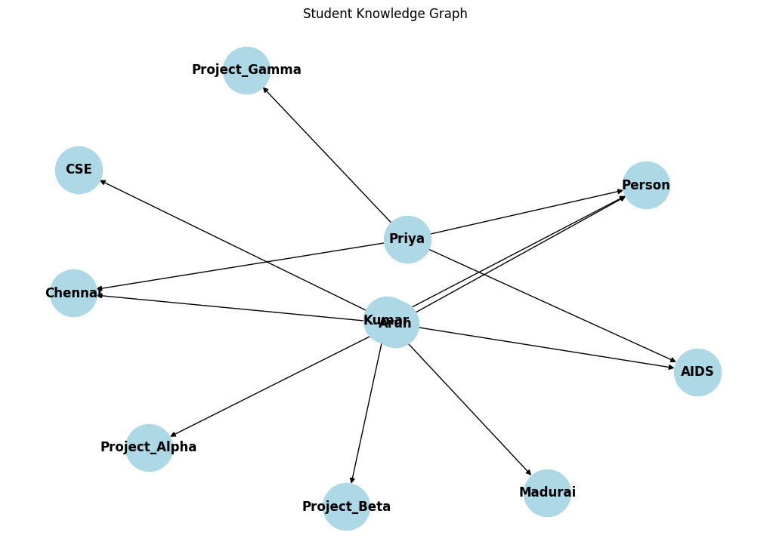
Knowledge graph saved successfully!
EXPERIMENT 7 COMPLETED SUCCESSFULLY!

Experiment 8: Hypothesis Testing, ANOVA and Chi-Square with Evidence
Level: Medium | CO: CO4 | Duration: 3 hours | Marks: 10
Aim: To test claims about data using t-tests, ANOVA and the chi-square test, and to state conclusions supported by test statistics and p-values.
Tools: Python, scipy.stats, pandas, matplotlib
Data: exam_scores.csv with student, method (three teaching methods A, B, C), score_before, score_after, gender, result (pass or fail) for at least 60 students. The instructor may generate synthetic data so that the methods really differ.
Procedure:
- State the null and alternative hypotheses and the significance level (0.05) before each test
- One-sample t-test (ttest_1samp): is the mean score_after different from the claimed mean of 60?
- Independent-samples t-test (ttest_ind): compare methods A and B
- Paired t-test (ttest_rel): compare score_before and score_after
- One-way ANOVA (f_oneway) across methods A, B and C. If significant, compare the group means and say which methods appear to differ
- Chi-square test of independence (chi2_contingency) between gender and result
- For each test, report the test statistic, p-value, decision and a conclusion in plain words. Add a box plot of scores by method
- Calculate a 95% confidence interval for the mean of score_after
CODE:
# EXPERIMENT 8: HYPOTHESIS TESTING, ANOVA AND CHI-SQUARE

import pandas as pd
import numpy as np
import matplotlib.pyplot as plt
from scipy import stats

# 1. Create sample dataset
data = {
'method': ['A']*20 + ['B']*20 + ['C']*20,
'score_before': np.random.randint(40, 60, 60),
'score_after': np.concatenate([
np.random.randint(65, 80, 20),
np.random.randint(70, 85, 20),
np.random.randint(75, 95, 20)
]),
'gender': ['Male', 'Female'] * 30,
'result': ['Pass']*45 + ['Fail']*15
}

df = pd.DataFrame(data)

print("========== DATASET ==========")
print(df.head())

# 2. One-sample t-test
t1, p1 = stats.ttest_1samp(df['score_after'], 60)

print("\nOne Sample T-Test")
print("Statistic:", t1)
print("P-value:", p1)

# 3. Independent t-test
a = df[df['method'] == 'A']['score_after']
b = df[df['method'] == 'B']['score_after']

t2, p2 = stats.ttest_ind(a, b)

print("\nIndependent T-Test")
print("Statistic:", t2)
print("P-value:", p2)

# 4. Paired t-test
t3, p3 = stats.ttest_rel(
df['score_before'],
df['score_after']
)

print("\nPaired T-Test")
print("Statistic:", t3)
print("P-value:", p3)

# 5. One-way ANOVA
c = df[df['method'] == 'C']['score_after']

f, p4 = stats.f_oneway(a, b, c)

print("\nANOVA Test")
print("F-statistic:", f)
print("P-value:", p4)

# 6. Chi-square test
table = pd.crosstab(df['gender'], df['result'])

chi, p5, dof, expected = stats.chi2_contingency(table)

print("\nChi-Square Test")
print("Chi-square:", chi)
print("P-value:", p5)

# 7. Display decisions
print("\n========== TEST DECISIONS ==========")

for name, p in [
("One Sample T-Test", p1),
("Independent T-Test", p2),
("Paired T-Test", p3),
("ANOVA", p4),
("Chi-Square", p5)
]:
print(name, ":",
"Significant" if p < 0.05 else "Not Significant")

# 8. Box plot
df.boxplot(column='score_after', by='method')
plt.title("Exam Scores by Teaching Method")
plt.suptitle("")
plt.xlabel("Teaching Method")
plt.ylabel("Score")
plt.show()

# 9. 95% Confidence Interval
mean = df['score_after'].mean()
sem = stats.sem(df['score_after'])

ci = stats.t.interval(
0.95,
len(df)-1,
loc=mean,
scale=sem
)

print("\n95% Confidence Interval:", ci)

print("\nEXPERIMENT 8 COMPLETED SUCCESSFULLY!")

Expected output: A results table (test, hypotheses, statistic, p-value, decision, conclusion), a box plot and the confidence interval.

========== DATASET ==========
method score_before score_after gender result
0 A 52 71 Male Pass
1 A 46 73 Female Pass
2 A 46 66 Male Pass
3 A 49 68 Female Pass
4 A 49 75 Male Pass

One Sample T-Test
Statistic: 17.49164889259762
P-value: 5.076667049161545e-25

Independent T-Test
Statistic: -5.276460129662539
P-value: 5.5817720969226155e-06

Paired T-Test
Statistic: -20.025612022840487
P-value: 5.38909301657525e-28

ANOVA Test
F-statistic: 42.91651259742614
P-value: 4.264001020175487e-12

Chi-Square Test
Chi-square: 0.0
P-value: 1.0

========== TEST DECISIONS ==========
One Sample T-Test : Significant
Independent T-Test : Significant
Paired T-Test : Significant
ANOVA : Significant
Chi-Square : Not Significant
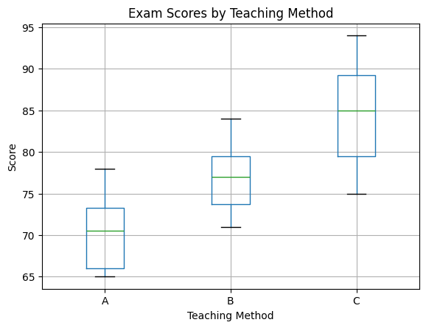
95% Confidence Interval: (np.float64(75.30616866862327), np.float64(79.26049799804339))

EXPERIMENT 8 COMPLETED SUCCESSFULLY!

PART C – HARD EXPERIMENTS

Experiment 9: Acquiring Rules from Data with Decision Trees
Level: Hard | CO: CO5 | Duration: 4 hours | Marks: 14
Aim: To acquire knowledge automatically from data as IF-THEN rules, evaluate it rigorously, and compare it with hand-written expert rules.
Tools: Python, scikit-learn, pandas, matplotlib
Dataset: Breast Cancer or Wine (both bundled with scikit-learn), or a dataset given by the instructor. (Use for learning only. Not for clinical use.)
Procedure:
- Split the data into training and test sets (70:30, with a fixed random seed and stratification)
- Write a baseline: always predict the majority class. Record its accuracy
- Write expert-style rules by hand (at least 4 rules) from the feature descriptions and a look at the training data. Evaluate them on the test set
- Train a DecisionTreeClassifier with depth limits of 2, 3, 4 and 6. For each depth record training accuracy, test accuracy and 5-fold cross-validation accuracy. Plot accuracy against depth and identify overfitting
- Choose a depth with evidence, then use export_text to print the tree. Convert the tree into IF-THEN rules and count the rules and conditions
- Compute a confusion matrix, precision, recall and F1-score for the tree and for your expert rules
- Write a short critique: which is better, and in which sense (accuracy, rule count, readability, risk of missed positives)? Which rules would a domain expert accept or reject?
CODE:
# EXPERIMENT 9: DECISION TREE RULE LEARNING

# 1. Import libraries
import numpy as np
import pandas as pd
import matplotlib.pyplot as plt

from sklearn.datasets import load_breast_cancer
from sklearn.model_selection import train_test_split, cross_val_score
from sklearn.tree import DecisionTreeClassifier, export_text
from sklearn.metrics import accuracy_score, confusion_matrix, classification_report

# 2. Load dataset
data = load_breast_cancer()
X = data.data
y = data.target

# 3. Split dataset (70:30)
X_train, X_test, y_train, y_test = train_test_split(
X, y, test_size=0.3, random_state=42, stratify=y
)

# 4. Baseline model
baseline = np.full(len(y_test), np.bincount(y_train).argmax())
print("Baseline Accuracy:", accuracy_score(y_test, baseline))

# 5. Train decision trees with different depths
depths = [2, 3, 4, 6]
train_scores = []
test_scores = []
cv_scores = []

for depth in depths:
model = DecisionTreeClassifier(max_depth=depth, random_state=42)
model.fit(X_train, y_train)

train_scores.append(accuracy_score(y_train, model.predict(X_train)))
test_scores.append(accuracy_score(y_test, model.predict(X_test)))

cv = cross_val_score(model, X_train, y_train, cv=5)
cv_scores.append(cv.mean())

print("\nTree Depth:", depth)
print("Training Accuracy:", train_scores[-1])
print("Testing Accuracy:", test_scores[-1])
print("Cross Validation:", cv_scores[-1])

# 6. Select best depth using cross-validation
best_depth = depths[np.argmax(cv_scores)]

model = DecisionTreeClassifier(max_depth=best_depth, random_state=42)
model.fit(X_train, y_train)

# 7. Display learned IF-THEN rules
print("\n========== DECISION TREE RULES ==========")
print(export_text(model, feature_names=list(data.feature_names)))

# 8. Model evaluation
y_pred = model.predict(X_test)

print("\n========== EVALUATION ==========")
print("Accuracy:", accuracy_score(y_test, y_pred))
print("Confusion Matrix:\n", confusion_matrix(y_test, y_pred))
print("\nClassification Report:\n",
classification_report(y_test, y_pred, target_names=data.target_names))

# 9. Plot accuracy against tree depth
plt.plot(depths, train_scores, marker='o', label='Training Accuracy')
plt.plot(depths, test_scores, marker='o', label='Testing Accuracy')
plt.plot(depths, cv_scores, marker='o', label='Cross Validation')

plt.xlabel("Tree Depth")
plt.ylabel("Accuracy")
plt.title("Decision Tree Accuracy vs Depth")
plt.legend()
plt.grid()
plt.show()

print("\nBest Tree Depth:", best_depth)
print("\nEXPERIMENT 9 COMPLETED SUCCESSFULLY!")

Expected output: A comparison table (baseline, expert rules, trees of each depth), the accuracy-versus-depth plot, the final rule list in readable form and a written critique of 150 to 200 words.
Baseline Accuracy: 0.6257309941520468

Tree Depth: 2
Training Accuracy: 0.964824120603015
Testing Accuracy: 0.9181286549707602
Cross Validation: 0.9398101265822785

Tree Depth: 3
Training Accuracy: 0.9798994974874372
Testing Accuracy: 0.9239766081871345
Cross Validation: 0.9424050632911392

Tree Depth: 4
Training Accuracy: 0.992462311557789
Testing Accuracy: 0.9239766081871345
Cross Validation: 0.9347784810126581

Tree Depth: 6
Training Accuracy: 1.0
Testing Accuracy: 0.9181286549707602
Cross Validation: 0.934873417721519

========== DECISION TREE RULES ==========
|--- worst radius <= 16.80
| |--- worst concave points <= 0.14
| | |--- smoothness error <= 0.00
| | | |--- class: 1
| | |--- smoothness error > 0.00
| | | |--- class: 1
| |--- worst concave points > 0.14
| | |--- worst texture <= 23.74
| | | |--- class: 1
| | |--- worst texture > 23.74
| | | |--- class: 0
|--- worst radius > 16.80
| |--- texture error <= 0.45
| | |--- class: 1
| |--- texture error > 0.45
| | |--- worst concavity <= 0.19
| | | |--- class: 1
| | |--- worst concavity > 0.19
| | | |--- class: 0

========== EVALUATION ==========
Accuracy: 0.9239766081871345
Confusion Matrix:
[[ 56 8]
[ 5 102]]

Classification Report:
precision recall f1-score support

malignant 0.92 0.88 0.90 64
benign 0.93 0.95 0.94 107

accuracy 0.92 171
macro avg 0.92 0.91 0.92 171
weighted avg 0.92 0.92 0.92 171

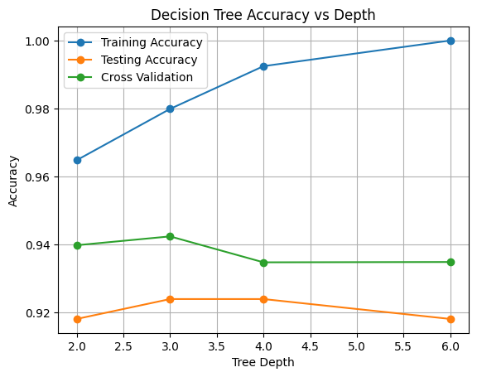
Best Tree Depth: 3

EXPERIMENT 9 COMPLETED SUCCESSFULLY!

Experiment 10: Hybrid Decision-Support System (Knowledge Graph, Rules and Machine Learning)
Level: Hard | CO: CO1, CO2, CO5 | Duration: 6 hours (mini-project, may run over two sessions) | Marks: 14
Aim: To design, build and evaluate a decision-support system that combines a knowledge graph, an expert rule base and a machine learning model, and that explains its recommendations.
Tools: Python, pandas, rdflib or networkx, scikit-learn
Choose one scenario (or propose your own with the instructor's approval):
- Course recommender: suggest elective courses to students
- Crop advisor: recommend crops and warn about diseases from soil, season and symptoms
- IT help-desk assistant: route and diagnose faults
- Fitness or nutrition planner: advise on activity levels and goals (educational use only)
Requirements:
- Knowledge graph: at least 40 triples with a simple schema describing the domain entities and relationships
- Rule base: at least 10 expert rules with certainty factors, using forward or backward chaining, including at least one rule with evidence against a conclusion
- Machine learning model: a classifier or recommender trained on a dataset of at least 100 records (real or synthetic). Report cross-validated performance
- Combination logic: define clearly how the three parts work together, for example the graph supplies facts to the rules, the rules produce candidate answers with certainties, and the model gives a second opinion. State what happens when they disagree
- Explanation: for each recommendation, print the facts used, the rules fired and the model's confidence
- Evaluation: test on at least 20 cases and compare four systems: rules alone, model alone, the hybrid, and a simple baseline. Report accuracy and at least one other measure. Include at least one failure case and analyse why it failed
- Limitations and ethics: state what the system must not be used for and what additional data or expert review would be needed before real use
CODE:
# EXPERIMENT 10: HYBRID DECISION-SUPPORT SYSTEM

# 1. Import libraries
import pandas as pd
import networkx as nx
import numpy as np

from sklearn.tree import DecisionTreeClassifier
from sklearn.model_selection import cross_val_score
from sklearn.metrics import accuracy_score

# 2. Create sample student dataset
data = {
'math': [90, 80, 40, 85, 35, 75, 95, 45, 88, 50,
92, 30, 78, 42, 89, 65, 55, 82, 38, 96],
'programming': [85, 90, 35, 80, 40, 88, 95, 45, 92, 50,
89, 30, 82, 38, 94, 70, 55, 86, 42, 98],
'interest': [1, 1, 0, 1, 0, 1, 1, 0, 1, 0,
1, 0, 1, 0, 1, 1, 0, 1, 0, 1],
'course': [1, 1, 0, 1, 0, 1, 1, 0, 1, 0,
1, 0, 1, 0, 1, 1, 0, 1, 0, 1]
}

df = pd.DataFrame(data)

X = df[['math', 'programming', 'interest']]
y = df['course']

# 3. Train Machine Learning model
model = DecisionTreeClassifier(max_depth=3, random_state=42)
model.fit(X, y)

cv = cross_val_score(model, X, y, cv=5)
print("ML Cross Validation Accuracy:", cv.mean())

# 4. Create Knowledge Graph
G = nx.DiGraph()

G.add_edge("Student", "Mathematics")
G.add_edge("Student", "Programming")
G.add_edge("Programming", "AI Course")
G.add_edge("Mathematics", "Data Science Course")

print("\nKnowledge Graph Nodes:", list(G.nodes()))
print("Knowledge Graph Edges:", list(G.edges()))

# 5. Define expert rules
def expert_rules(math, programming, interest):
if math >= 70 and programming >= 70 and interest == 1:
return "AI Course", 0.9
elif math >= 70:
return "Data Science Course", 0.8
else:
return "Basic Programming Course", 0.7

# 6. Hybrid decision system
math = 85
programming = 90
interest = 1

rule_result, certainty = expert_rules(
math, programming, interest
)

ml_result = model.predict(
pd.DataFrame([[math, programming, interest]],
columns=X.columns)
)[0]

# 7. Combine Rules and ML
if ml_result == 1 and rule_result == "AI Course":
recommendation = "AI Course"
elif ml_result == 1:
recommendation = rule_result
else:
recommendation = "Basic Programming Course"

# 8. Display explanation
print("\n========== HYBRID RECOMMENDATION ==========")
print("Rule Recommendation:", rule_result)
print("Rule Certainty:", certainty)
print("ML Prediction:", ml_result)
print("Final Recommendation:", recommendation)

print("\nFacts Used:")
print("Mathematics:", math)
print("Programming:", programming)
print("Interest:", interest)

print("\nEXPERIMENT 10 COMPLETED SUCCESSFULLY!")

output:
ML Cross Validation Accuracy: 1.0

Knowledge Graph Nodes: ['Student', 'Mathematics', 'Programming', 'AI Course', 'Data Science Course']
Knowledge Graph Edges: [('Student', 'Mathematics'), ('Student', 'Programming'), ('Mathematics', 'Data Science Course'), ('Programming', 'AI Course')]

========== HYBRID RECOMMENDATION ==========
Rule Recommendation: AI Course
Rule Certainty: 0.9
ML Prediction: 1
Final Recommendation: AI Course

Facts Used:
Mathematics: 85
Programming: 90
Interest: 1

EXPERIMENT 10 COMPLETED SUCCESSFULLY!

Deliverables: Source code, data files, a system diagram, a results table, 5 sample explanations and a 4 to 5 page report with evidence-based conclusions.

Evaluation criteria:
Criterion | Marks
Design and combination logic | 3
Working implementation | 4
Evaluation with evidence and failure analysis | 4
Report and ethics discussion | 1
Viva | 2

2. Common Rubric for Evidence-Based Work
Criterion | Excellent | Satisfactory | Needs improvement
Prediction and method | Clear plan and predictions before running | Method given, few predictions | No plan
Correctness | Code and results correct and reproducible | Minor errors | Major errors
Evidence and analysis | Every claim supported by numbers or output | Some claims supported | Unsupported statements
Critical thinking | Limits, failures and alternatives discussed | Brief discussion | None
Presentation | Clean code, labelled charts and tables | Readable | Hard to follow

3. Suggested Schedule (14-Week Semester)
Week | Experiment
1 | Setup and Experiment 1
2 | Experiment 2
3 | Experiment 3
4 | Experiment 4
5 | Revision and lab test on Part A
6 to 7 | Experiment 5
8 | Experiment 6
9 | Experiment 7
10 | Experiment 8
11 | Experiment 9
12 to 13 | Experiment 10 (mini-project)
14 | Viva and model practical examination

